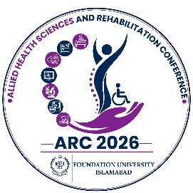
Allied Health Sciences & Rehabilitation Conference (ARC) 2026

Foundation University, Islamabad 25th-27th September 2026

ABSTRACT SUBMISSION TEMPLATE
Submit Abstract at XXXXX

Author(s): Underline the presenting author name.

Affiliation(s)
- Include all relevant affiliations and number according to authors.

Affiliations should NOT be referred to by acronyms but must be spelt out.

Email address/Contact/Mobile #

Corresponding Author:
Presenter:

Presentation Category/please tick

Oral Poster Plenary Invited *

Oral and poster

Indicate the theme that best suits your research*

- Neuro Rehabilitation
- Manual Therapy
- Pediatric Physical Therapy
- Cardiopulmonary Physical Therapy
- Sports Physical Therapy
- Women Health
- Speech Language Pathology/Therapy
- Prosthetics & Orthotics
- Audiology
- Medical Laboratory Technology
- Human Nutrition & Dietetics
- Medical Imaging Technology
- Optometry & Orthoptics
- Food Science & Technology
- Operation Theater Technology
- Others (Please Specify)

ABSTRACT TITLE:
- Use sentence case, i.e. capital letter on 1st word and any proper nouns only.

BACKGROUND:

OBJECTIVES:

METHODOLOGY:

RESULTS:

CONCLUSION:

KEY WORDS:

Step 1: [Upload File]
Step 2: [Submit]

